root@TCS4357:~# apt-get update
root@TCS4357:~# apt-cache dumpavail | grep -oP "(?<=Package: ).*" >> /tmp/packagelist
root@TCS4357:~# for var1 in $(egrep -ie "^a.*" /tmp/packagelist) ; do apt-get install --yes --no-install-recommends --download-only ${var1} ; done
root@TCS4357:~# ls -Alh /var/cache/apt/archives/ | wc -l
root@TCS4357:~# apt-get clean

https://launchpad.net/ubuntu/+archivemirrors
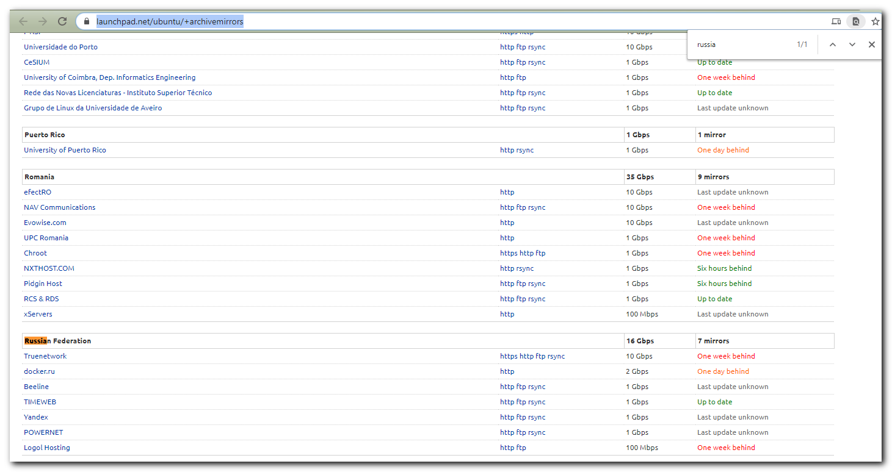
https://launchpad.net/ubuntu/+mirror/mirror.yandex.ru
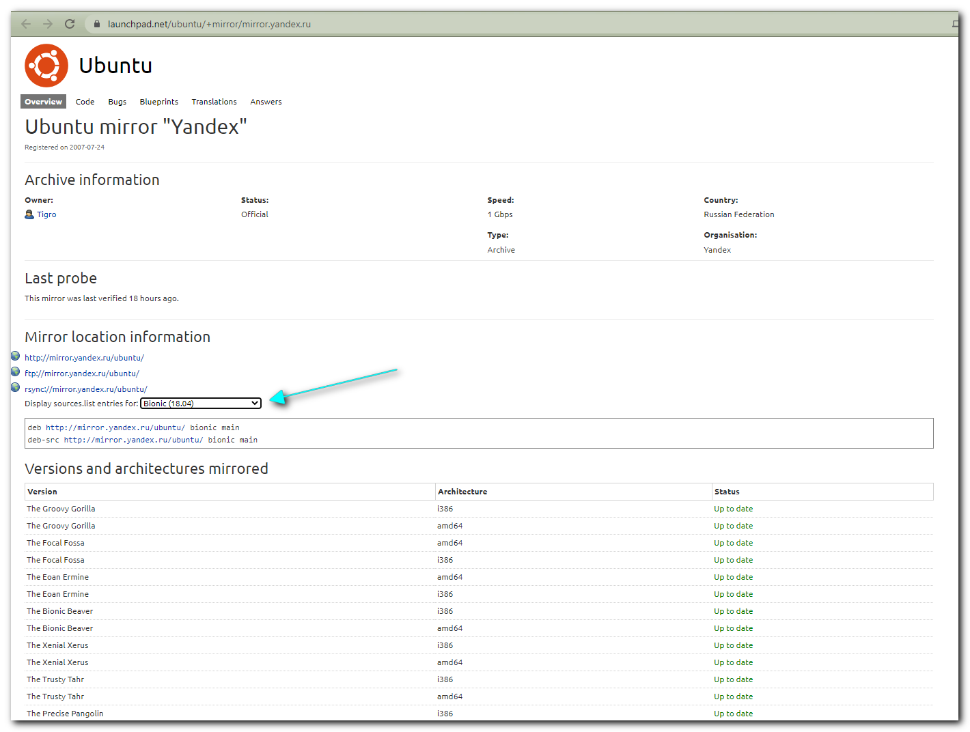

http://mirror.yandex.ru/ubuntu/
ftp://mirror.yandex.ru/ubuntu/
rsync://mirror.yandex.ru/ubuntu/

deb http://mirror.yandex.ru/ubuntu/ bionic main
deb-src http://mirror.yandex.ru/ubuntu/ bionic main

https://repogen.simplylinux.ch/
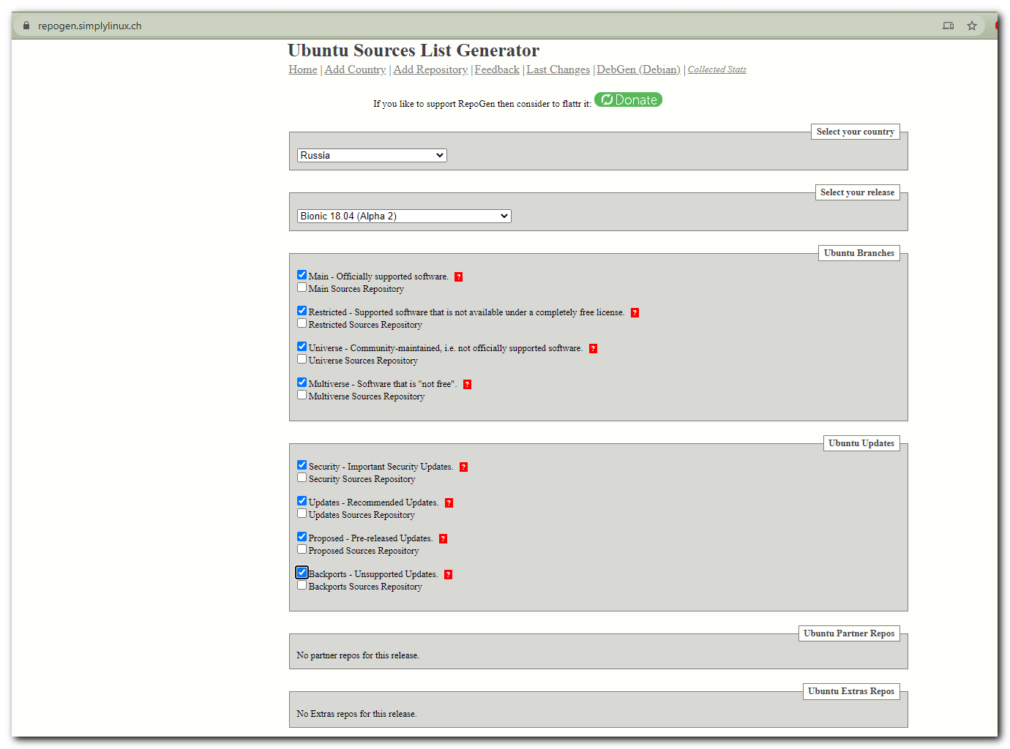

# The button “generate” at the end of page was pressed.
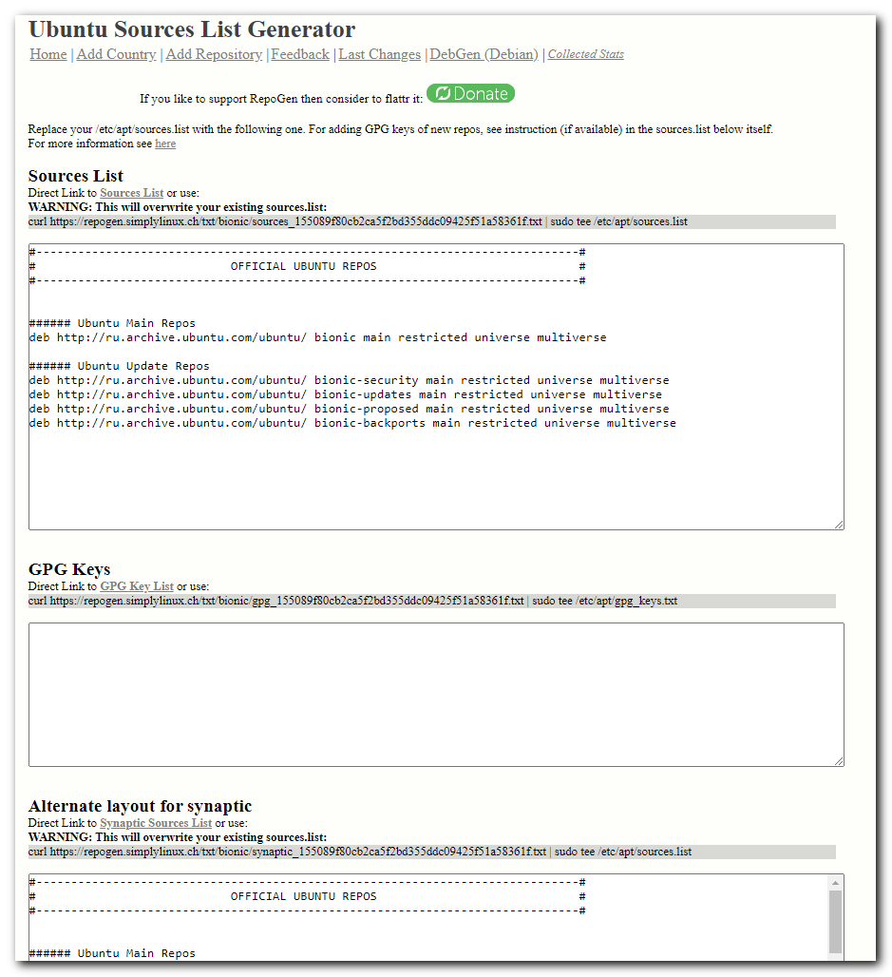

Replace your /etc/apt/sources.list with the following one. For adding GPG keys of new repos, see instruction (if available) in the sources.list below itself.
For more information see here

Sources List
Direct Link to Sources List or use:
WARNING: This will overwrite your existing sources.list:
curl https://repogen.simplylinux.ch/txt/bionic/sources_155089f80cb2ca5f2bd355ddc09425f51a58361f.txt | sudo tee /etc/apt/sources.list

#------------------------------------------------------------------------------#
# OFFICIAL UBUNTU REPOS #
#------------------------------------------------------------------------------#

###### Ubuntu Main Repos
deb http://ru.archive.ubuntu.com/ubuntu/ bionic main restricted universe multiverse

###### Ubuntu Update Repos
deb http://ru.archive.ubuntu.com/ubuntu/ bionic-security main restricted universe multiverse
deb http://ru.archive.ubuntu.com/ubuntu/ bionic-updates main restricted universe multiverse
deb http://ru.archive.ubuntu.com/ubuntu/ bionic-proposed main restricted universe multiverse
deb http://ru.archive.ubuntu.com/ubuntu/ bionic-backports main restricted universe multiverse

GPG Keys
Direct Link to GPG Key List or use:
curl https://repogen.simplylinux.ch/txt/bionic/gpg_155089f80cb2ca5f2bd355ddc09425f51a58361f.txt | sudo tee /etc/apt/gpg_keys.txt

Alternate layout for synaptic
Direct Link to Synaptic Sources List or use:
WARNING: This will overwrite your existing sources.list:
curl https://repogen.simplylinux.ch/txt/bionic/synaptic_155089f80cb2ca5f2bd355ddc09425f51a58361f.txt | sudo tee /etc/apt/sources.list

#------------------------------------------------------------------------------#
# OFFICIAL UBUNTU REPOS #
#------------------------------------------------------------------------------#

###### Ubuntu Main Repos
deb http://ru.archive.ubuntu.com/ubuntu/ bionic main restricted universe multiverse

###### Ubuntu Update Repos
deb http://ru.archive.ubuntu.com/ubuntu/ bionic-security main restricted universe multiverse
deb http://ru.archive.ubuntu.com/ubuntu/ bionic-updates main restricted universe multiverse
deb http://ru.archive.ubuntu.com/ubuntu/ bionic-proposed main restricted universe multiverse
deb http://ru.archive.ubuntu.com/ubuntu/ bionic-backports main restricted universe multiverse

ubuntu-snapshot-202010xx
http://mirror.yandex.ru/ubuntu/

# I don’t know for what “Content Disposition” exists. I set it to “Inline”. It’s just an test.
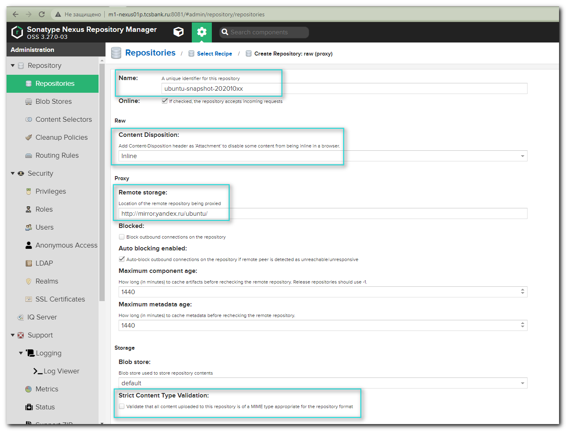
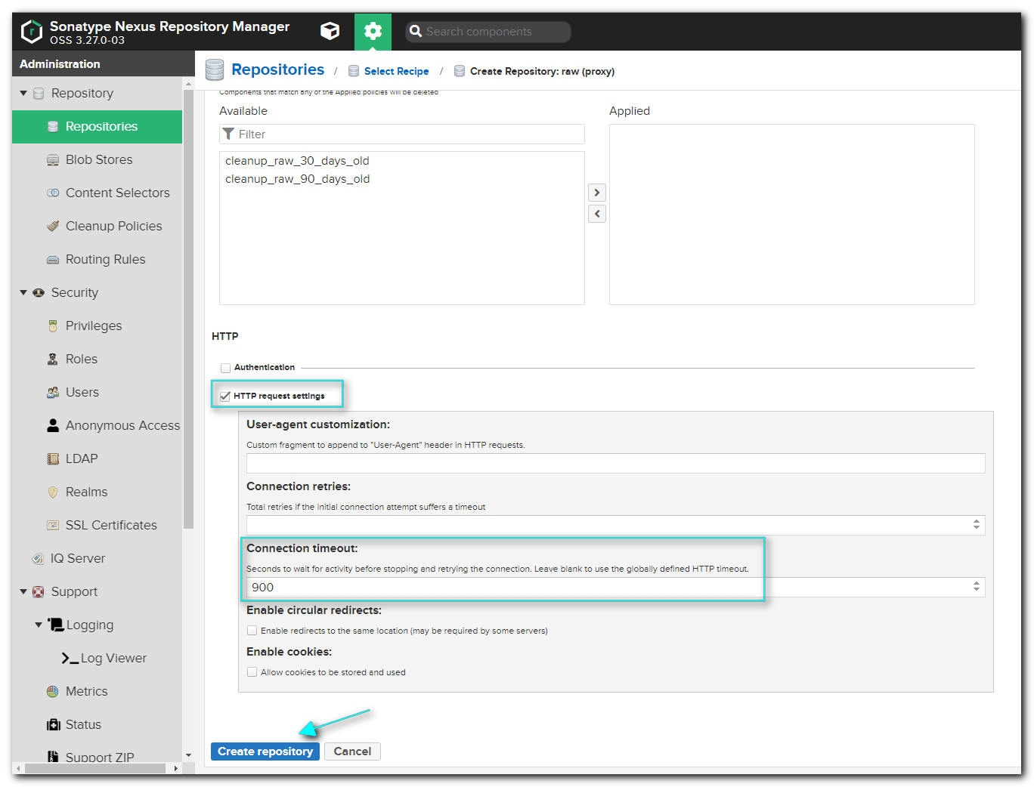

# Here is after configuration for repository was created.
http://m1-nexus01p.tcsbank.ru:8081/repository/ubuntu-snapshot-202010xx/

http://repo-linux.tcsbank.ru/repository/ubuntu-snapshot-202010xx/

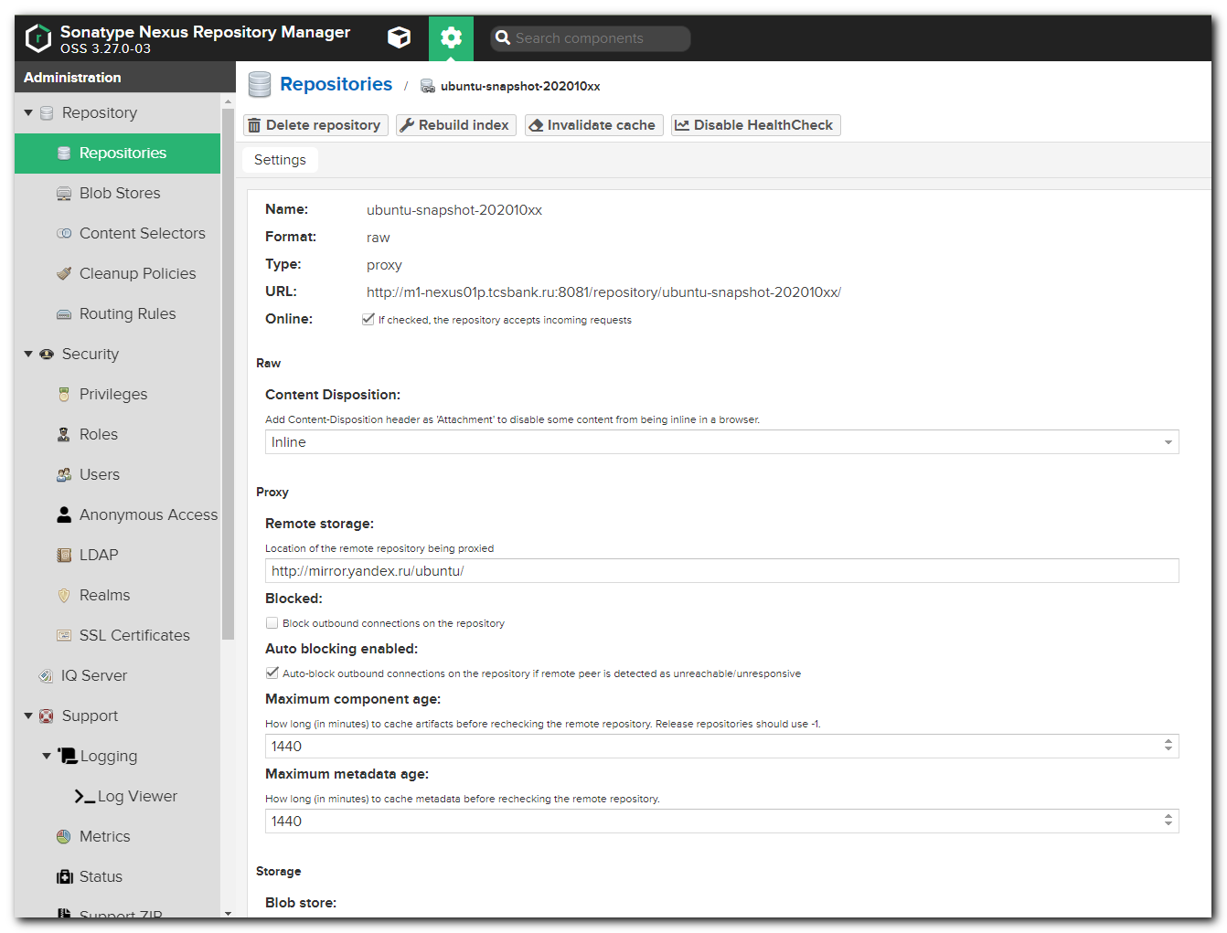

root@TCS4357:~# apt install apt-mirror
Reading package lists... Done
Building dependency tree
Reading state information... Done
The following packages were automatically installed and are no longer required:
ieee-data python-netaddr python-selinux
Use 'sudo apt autoremove' to remove them.
The following NEW packages will be installed:
apt-mirror
0 upgraded, 1 newly installed, 0 to remove and 266 not upgraded.
Need to get 13.5 kB of archives.
After this operation, 64.5 kB of additional disk space will be used.
Get:1 http://repo-linux.tcsbank.ru/repository/ubuntu-apt-xenial xenial/universe amd64 apt-mirror all 0.5.1-1ubuntu1 [13.5 kB]
Fetched 13.5 kB in 0s (22.4 kB/s)
Selecting previously unselected package apt-mirror.
(Reading database ... 42441 files and directories currently installed.)
Preparing to unpack .../apt-mirror_0.5.1-1ubuntu1_all.deb ...
Unpacking apt-mirror (0.5.1-1ubuntu1) ...
Processing triggers for man-db (2.7.5-1) ...
Setting up apt-mirror (0.5.1-1ubuntu1) ...
root@TCS4357:~#

root@TCS4357:~# mkdir -p ~/work/20201021-1309/backup
root@TCS4357:~# cp /etc/apt/mirror.list ~/work/20201021-1309/backup/
root@TCS4357:~# vim /etc/apt/mirror.list

:'<,'>s/archive.ubuntu.com/repo-linux.tcsbank.ru\/repository\/ubuntu-snapshot-202010xx/gc

root@TCS4357:~# cat /etc/apt/mirror.list
############# config ##################
#
# set base_path /var/spool/apt-mirror
#
# set mirror_path $base_path/mirror
# set skel_path $base_path/skel
# set var_path $base_path/var
# set cleanscript $var_path/clean.sh
# set defaultarch <running host architecture>
# set postmirror_script $var_path/postmirror.sh
# set run_postmirror 0
set nthreads 20
set _tilde 0
#
############# end config ##############

deb http://repo-linux.tcsbank.ru/repository/ubuntu-snapshot-202010xx/ubuntu xenial main restricted universe multiverse
deb http://repo-linux.tcsbank.ru/repository/ubuntu-snapshot-202010xx/ubuntu xenial-security main restricted universe multiverse
deb http://repo-linux.tcsbank.ru/repository/ubuntu-snapshot-202010xx/ubuntu xenial-updates main restricted universe multiverse
#deb http://repo-linux.tcsbank.ru/repository/ubuntu-snapshot-202010xx/ubuntu xenial-proposed main restricted universe multiverse
#deb http://repo-linux.tcsbank.ru/repository/ubuntu-snapshot-202010xx/ubuntu xenial-backports main restricted universe multiverse

#deb-src http://repo-linux.tcsbank.ru/repository/ubuntu-snapshot-202010xx/ubuntu xenial main restricted universe multiverse
#deb-src http://repo-linux.tcsbank.ru/repository/ubuntu-snapshot-202010xx/ubuntu xenial-security main restricted universe multiverse
#deb-src http://repo-linux.tcsbank.ru/repository/ubuntu-snapshot-202010xx/ubuntu xenial-updates main restricted universe multiverse
#deb-src http://repo-linux.tcsbank.ru/repository/ubuntu-snapshot-202010xx/ubuntu xenial-proposed main restricted universe multiverse
#deb-src http://repo-linux.tcsbank.ru/repository/ubuntu-snapshot-202010xx/ubuntu xenial-backports main restricted universe multiverse

clean http://archive.ubuntu.com/ubuntu

# 20201021
# Backup
#
# deb http://archive.ubuntu.com/ubuntu xenial main restricted universe multiverse
# deb http://archive.ubuntu.com/ubuntu xenial-security main restricted universe multiverse
# deb http://archive.ubuntu.com/ubuntu xenial-updates main restricted universe multiverse
# #deb http://archive.ubuntu.com/ubuntu xenial-proposed main restricted universe multiverse
# #deb http://archive.ubuntu.com/ubuntu xenial-backports main restricted universe multiverse
#
# deb-src http://archive.ubuntu.com/ubuntu xenial main restricted universe multiverse
# deb-src http://archive.ubuntu.com/ubuntu xenial-security main restricted universe multiverse
# deb-src http://archive.ubuntu.com/ubuntu xenial-updates main restricted universe multiverse
# #deb-src http://archive.ubuntu.com/ubuntu xenial-proposed main restricted universe multiverse
# #deb-src http://archive.ubuntu.com/ubuntu xenial-backports main restricted universe multiverse
root@TCS4357:~#

root@TCS4357:~# apt-mirror
Downloading 114 index files using 20 threads...
wget: error while loading shared libraries: libuuid.so.1: cannot open shared object file: No such file or directory
wget: error while loading shared libraries: libuuid.so.1: cannot open shared object file: No such file or directory
wget: error while loading shared libraries: libuuid.so.1: cannot open shared object file: No such file or directory
Begin time: Wed Oct 21 13:25:11 2020
[20]... [19]... [18]... [17]... wget: Cannot read /etc/wgetrc (Permission denied).
[16]... [15]... [14]... [13]... [12]... [11]... [10]... [9]... [8]... [7]... [6]... [5]... [4]... [3]... [2]... [1]... [0]...
End time: Wed Oct 21 13:25:35 2020

Processing tranlation indexes: [TTT]

Downloading 558 translation files using 20 threads...
Can't exec "wget": Permission denied at /usr/bin/apt-mirror line 256.

Could not run wget, please make sure its installed and in your path

Can't exec "wget": Permission denied at /usr/bin/apt-mirror line 256.
...

root@TCS4357:~# apt install wget
Reading package lists... Done
Building dependency tree
Reading state information... Done
The following packages were automatically installed and are no longer required:
ieee-data python-netaddr python-selinux
Use 'sudo apt autoremove' to remove them.
The following packages will be upgraded:
wget
1 upgraded, 0 newly installed, 0 to remove and 265 not upgraded.
Need to get 299 kB of archives.
After this operation, 4,096 B of additional disk space will be used.
Get:1 http://repo-linux.tcsbank.ru/repository/ubuntu-apt-xenial xenial-updates/main amd64 wget amd64 1.17.1-1ubuntu1.5 [299 kB]
Fetched 299 kB in 1s (260 kB/s)
(Reading database ... 42452 files and directories currently installed.)
Preparing to unpack .../wget_1.17.1-1ubuntu1.5_amd64.deb ...
Unpacking wget (1.17.1-1ubuntu1.5) over (1.17.1-1ubuntu1.2) ...
Processing triggers for install-info (6.1.0.dfsg.1-5) ...
Processing triggers for man-db (2.7.5-1) ...
Setting up wget (1.17.1-1ubuntu1.5) ...
root@TCS4357:~#

# Were same errors...

root@TCS4357:~# vim /etc/apt/mirror.list
root@TCS4357:~# ls -Alh /var/spool/apt-mirror
total 0
drwxr-xr-x 1 apt-mirror apt-mirror 4.0K Oct 21 13:28 mirror
drwxr-xr-x 1 apt-mirror apt-mirror 4.0K Oct 21 13:25 skel
drwxr-xr-x 1 apt-mirror apt-mirror 4.0K Oct 21 13:28 var
root@TCS4357:~# du -sh /var/spool/apt-mirror
706M /var/spool/apt-mirror
root@TCS4357:~#

root@TCS4357:~# apt-mirror
Downloading 114 index files using 2 threads...
Begin time: Wed Oct 21 13:32:02 2020
[2]... Can't exec "wget": Permission denied at /usr/bin/apt-mirror line 256.

Could not run wget, please make sure its installed and in your path

[1]... [0]...
End time: Wed Oct 21 13:32:03 2020

Processing tranlation indexes: [TTT]

Downloading 564 translation files using 2 threads...
Begin time: Wed Oct 21 13:32:03 2020
[2]... Can't exec "wget": Permission denied at /usr/bin/apt-mirror line 256.

Could not run wget, please make sure its installed and in your path

[1]... [0]...
End time: Wed Oct 21 13:32:24 2020

Processing DEP-11 indexes: [DDD]

Downloading 54 dep11 files using 2 threads...
Begin time: Wed Oct 21 13:32:24 2020
[2]... Can't exec "wget": Permission denied at /usr/bin/apt-mirror line 256, <STREAM> line 18732.

Could not run wget, please make sure its installed and in your path

[1]... [0]...
End time: Wed Oct 21 13:32:28 2020

Processing indexes: [PPP]

152.8 GiB will be downloaded into archive.
Downloading 69204 archive files using 2 threads...
Begin time: Wed Oct 21 13:32:35 2020
[2]...

root@TCS4357:~# du -sh /var/spool/apt-mirror/
6.3G /var/spool/apt-mirror/
root@TCS4357:~#

root@TCS4357:~# ls -Alh /var/spool/apt-mirror/mirror/repo-linux.tcsbank.ru/repository/ubuntu-snapshot-202010xx/ubuntu/pool/ | head
total 0
drwxr-xr-x 1 root root 4.0K Oct 21 13:39 main
drwxr-xr-x 1 root root 4.0K Oct 21 13:28 multiverse
drwxr-xr-x 1 root root 4.0K Oct 21 13:33 universe
root@TCS4357:~# ls -Alh /var/spool/apt-mirror/mirror/repo-linux.tcsbank.ru/repository/ubuntu-snapshot-202010xx/ubuntu/pool/main/ | head
total 0
drwxr-xr-x 1 root root 4.0K Oct 21 13:38 a
drwxr-xr-x 1 root root 4.0K Oct 21 13:39 b
drwxr-xr-x 1 root root 4.0K Oct 21 13:39 c
drwxr-xr-x 1 root root 4.0K Oct 21 13:28 i
drwxr-xr-x 1 root root 4.0K Oct 21 13:28 l
drwxr-xr-x 1 root root 4.0K Oct 21 13:28 p
root@TCS4357:~#

...
71.8 GiB will be downloaded into archive.
Downloading 16688 archive files using 2 threads...
Begin time: Wed Oct 21 14:10:55 2020
[2]...

# In parallel terminal window. To reduce occupied space by downloaded software.
root@TCS4357:~# find /mnt/c/share/ubuntu_repository_mirror/mirror/ -type f -not -newerct "2020-10-21 17:00" -exec rm {} \;

root@TCS4357:~# find /mnt/c/share/ubuntu_repository_mirror/mirror/ -type f -not -newerct "$(date "+%Y-%m-%d %H:%M" -d "now - 1 hour")" -exec rm {} \;
root@TCS4357:~# du -sh /mnt/c/share/ubuntu_repository_mirror
9.1G /mnt/c/share/ubuntu_repository_mirror
root@TCS4357:~#

#
# To suppress useless output in console after download finished.
#
support@TCS4357:~$ less /mnt/c/share/ubuntu_repository_mirror/var/archive-log.0
support@TCS4357:~$ vim -o /mnt/c/share/ubuntu_repository_mirror/var/{clean.sh,postmirror.sh}
2 files to edit
support@TCS4357:~$ cat /mnt/c/share/ubuntu_repository_mirror/var/{clean.sh,postmirror.sh}
#!/bin/sh
set -e
.
# cd /mnt/c/share/ubuntu_repository_mirror/mirror
#
# echo 'Removing 0 unnecessary files [0 bytes]...'
# echo 'done.'
# echo
#
# echo 'Removing 0 unnecessary directories...'
# echo 'done.'
# echo

#!/bin/sh
set -e
.
support@TCS4357:~$

#
# To watch online downloading process.
support@TCS4357:~$ less /mnt/c/share/ubuntu_repository_mirror/var/archive-log.0

Название проекта: Nexus Repository Manager
Краткое описание: Создание и управление регулярными месячными копиями внешних репозиториев программ для Ubuntu
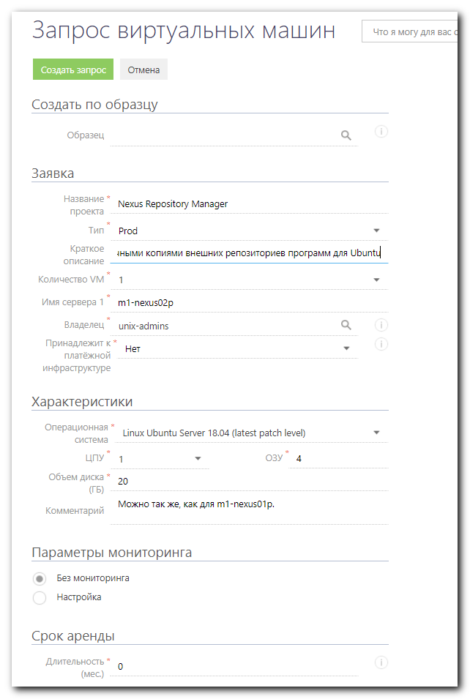
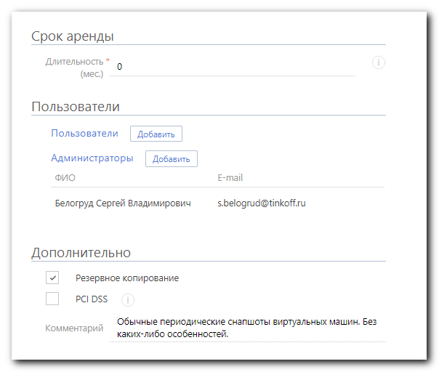
https://fsd.tcsbank.ru/case/4562989/info
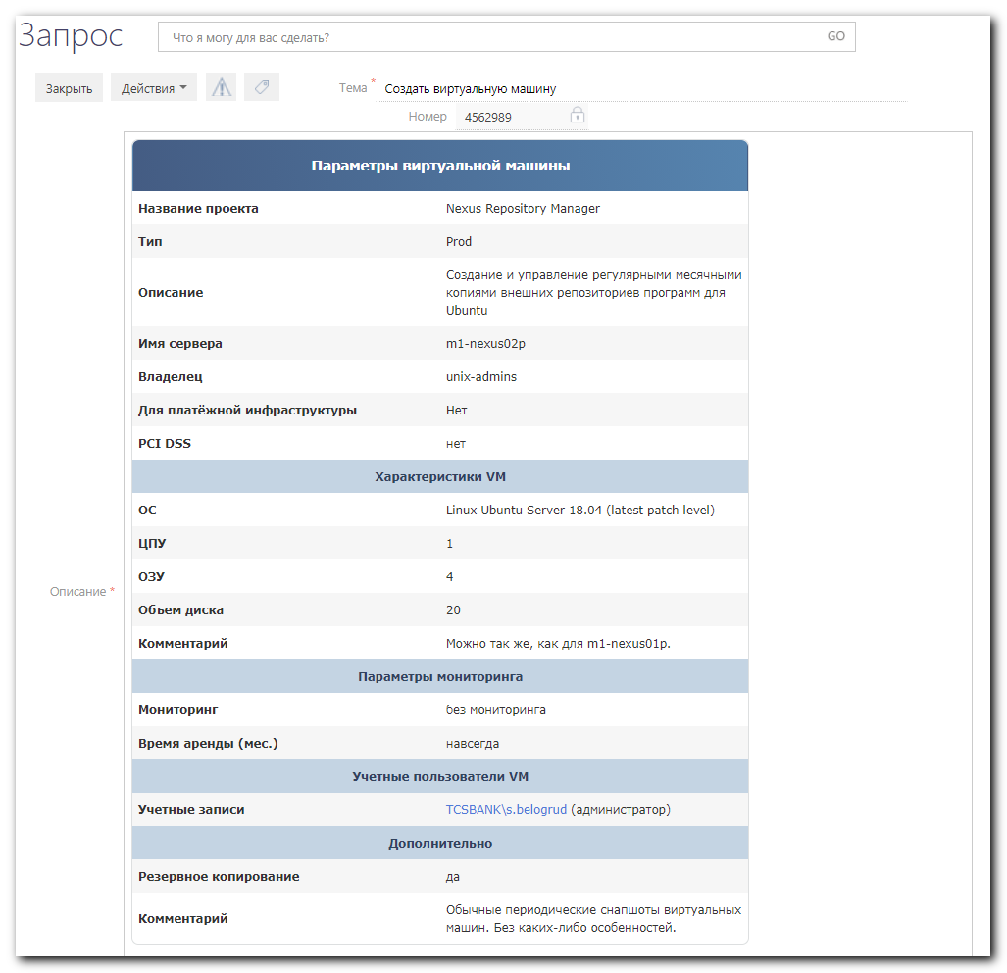

https://fsd.tcsbank.ru/case/4563385/info
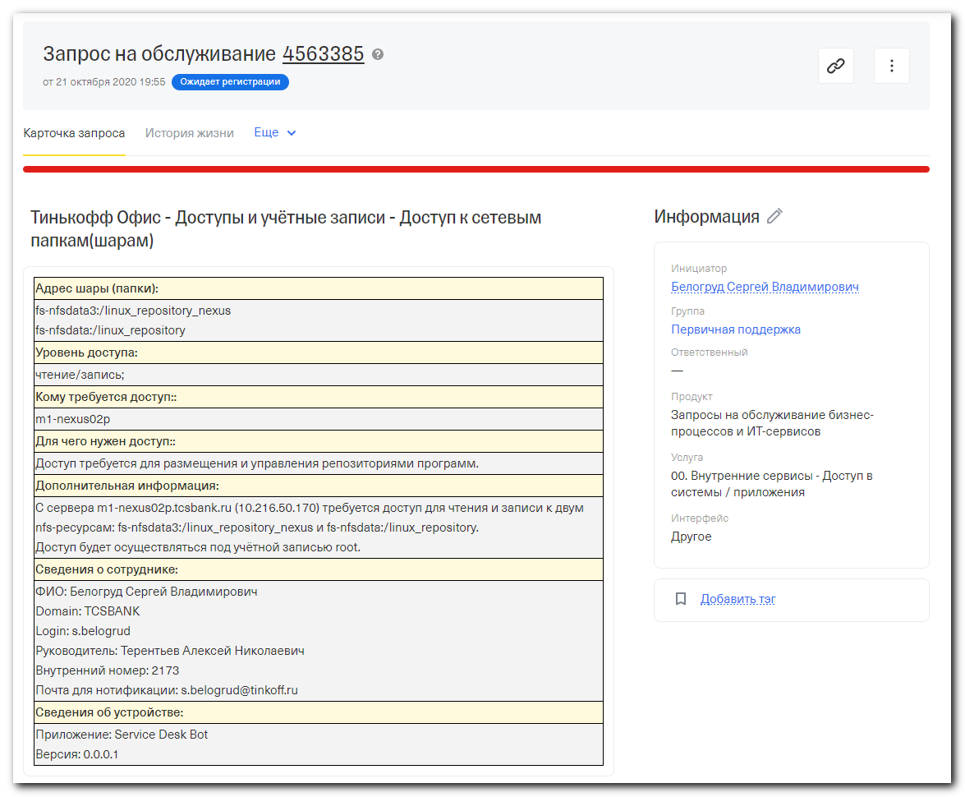

#
# I set zerro for both lines.
root@m1-nexus02p:~# cat /etc/apt/apt.conf.d/20auto-upgrades
APT::Periodic::Update-Package-Lists "0";
APT::Periodic::Unattended-Upgrade "0";
root@m1-nexus02p:~#

https://askubuntu.com/questions/531403/how-to-download-all-repository-using-apt-get
...
First of all, this is not a convenient way. Instead of this you should use the method mention here. But as an answer to the question.

First create a file which contains names of all the available packages using apt-cache.

apt-cache dumpavail |grep -oP "(?<=Package: ).*" >> packagelist
This will create a file packagelist with all the available packages.

Now create a simple script to download all the packages present in the file packagelist

#!/bin/bash
for package in `cat packagelist`
do
apt-get install -y --download-only $package
done
Save it.

Make it executable using

chmod +x your_script_name
Now open terminal and login as root

sudo -i
cd /folder/of/you/script
./you_script_name
It will download all the available package depending upon your /etc/apt/sources.list in /var/cache/apt/archives directory

https://unix.stackexchange.com/questions/302495/how-to-download-packages-from-a-command-line-given-repository

https://wiki.debian.org/DebianRepository/Format?action=show&redirect=RepositoryFormat
Debian Repository Format

https://danie1.me/2019/01/14/how-to-download-ubuntu-18-04-bionic-repository-for-offline/

How to download Ubuntu 18.04 / Bionic repository for offline
Daniel Technology January 14, 2019 | 24
It’s time for a more technical post on Developer Daniel.
Nobody in their right mind downloads hundreds of gigabytes of data without a cause. So you’re probably reading this because you are in the following position:
- You work in an “air-gapped” network and would like to transfer the whole Ubuntu repository into your organization’s network.
- You’d like to have the ability to download and install packages without persistent internet connection in the future.
- You tend to Google random queries.
- You are a humanitarian and would like to expand the variety of Ubuntu archive mirrors in the world. Cheers!
I hope you have a fast internet connection, and at least 150GB space left on your hard disk. This may take over a day (depends on your Ubuntu repository archive).

Step 1 – Choose your favorite Ubuntu Archive Mirror Site
Go to Official Archive Mirrors for Ubuntu and choose a mirror to download from:
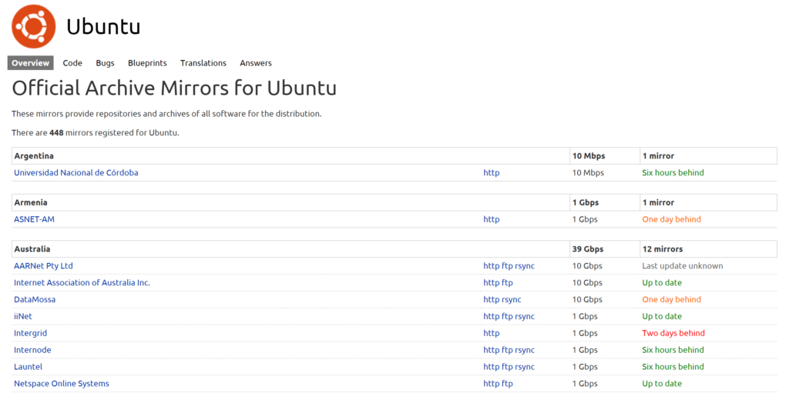
You can see how fast each mirror is and how stable they are.
Once you choose an official mirror, click it and copy its URL. You will need it for later on. The URL has been highlighted in red:
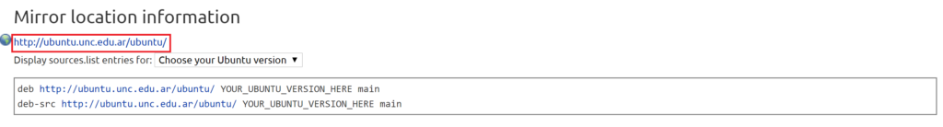

Step 2 – Generate or copy a sources.list file
So far, you have a mirror archive to download from. It’s time to choose which repositories you would like to download from it. That is the purpose of the sources.list file found in /etc/apt/sources.list.
For this step, either copy your local sources.list file contents, copy the following snippet or generate one on https://repogen.simplylinux.ch.
Here is an example sources.list file:
###### Ubuntu Main Repos
deb http://il.archive.ubuntu.com/ubuntu/ bionic main restricted universe multiverse
deb-src http://il.archive.ubuntu.com/ubuntu/ bionic main restricted universe multiverse

###### Ubuntu Update Repos
deb http://il.archive.ubuntu.com/ubuntu/ bionic-security main restricted universe multiverse
deb http://il.archive.ubuntu.com/ubuntu/ bionic-updates main restricted universe multiverse
deb http://il.archive.ubuntu.com/ubuntu/ bionic-proposed main restricted universe multiverse
deb http://il.archive.ubuntu.com/ubuntu/ bionic-backports main restricted universe multiverse
deb-src http://il.archive.ubuntu.com/ubuntu/ bionic-security main restricted universe multiverse
deb-src http://il.archive.ubuntu.com/ubuntu/ bionic-updates main restricted universe multiverse
deb-src http://il.archive.ubuntu.com/ubuntu/ bionic-proposed main restricted universe multiverse
deb-src http://il.archive.ubuntu.com/ubuntu/ bionic-backports main restricted universe multiverse
If you decided to go with a different archive mirror, you will need to substitute the URL you copied with the one in the sources.list.
Important for those who want both 32bit and 64bit support: By default, apt-mirror will only download the packages for the host’s architecture. This would mean that if you run this on a 64bit machine, only the 64bit packages will be downloaded. In order to download both, for every ‘deb …’ change it to ‘deb-amd64’ or ‘deb-i386’ (you can have both).
For example, this:
deb http://il.archive.ubuntu.com/ubuntu/ bionic-security main restricted universe multiverse
deb-src http://il.archive.ubuntu.com/ubuntu/ bionic main restricted universe multiverse
Should look like this:
deb-i386 http://il.archive.ubuntu.com/ubuntu/ bionic-security main restricted universe multiverse
deb-amd64 http://il.archive.ubuntu.com/ubuntu/ bionic-security main restricted universe multiverse
deb-src http://il.archive.ubuntu.com/ubuntu/ bionic main restricted universe multiverse

Step 3 – Install & Configure apt-mirror
Run in the terminal to install apt-mirror:
sudo apt install apt-mirror
Configure apt-mirror with your favorite editor in /etc/apt/mirror.list. You may also copy mine:
############# config ##################
#
set base_path /your/path/here
#
# set mirror_path $base_path/mirror
# set skel_path $base_path/skel
# set var_path $base_path/var
# set cleanscript $var_path/clean.sh
# set defaultarch <running host architecture>
# set postmirror_script $var_path/postmirror.sh
# set run_postmirror 0
set nthreads 20
set _tilde 0
#
############# end config ##############

# DUMP YOUR sources.list CONTENTS HERE WITHOUT THE '#'!

Make sure to update the ‘base_path’ configuration to the path where you’d like to find your downloaded repositories in. It must exist on your file system! For example, I created a ‘BionicRepo’ directory in my Downloads directory, so I configured the <base_path> to: /home/daniel/Downloads/BionicRepo.
Don’t forget to dump Step 2’s sources.list contents at the end of the mirror.list file.
* There are more configuration options which I will not walk through in this guide. For example, you can change the number of threads (‘set nthreads 20’) that download the repositories at once. In this case, there are 20 threads that perform the work. I don’t advise to change these configurations if you’re not sure with what you are doing.
Once you have that settled, it’s time for you to prove yourself how patient you can be!

Step 4 – Run the apt-mirror command
Run as the apt-mirror user:
sudo su apt-mirror
apt-mirror
Now wait until it finishes. This may take over a day (depending on the archive mirror you chose and the number of repositories you are downloading).
SANITY CHECK: If you got everything correctly up until now, you should see something like this:
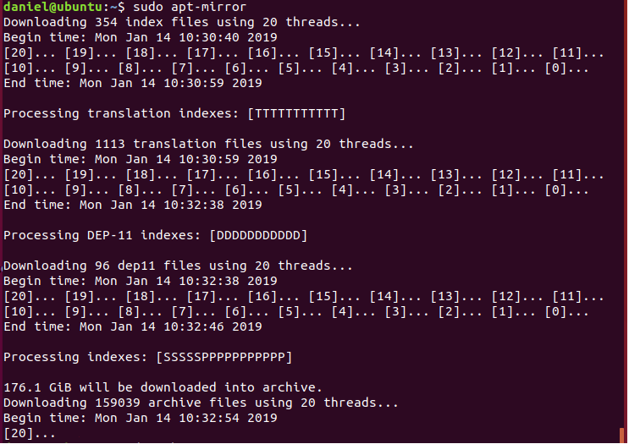
And when you check the size of your <base_path>, it is increasing in size.

Step 5 – Download Complete
Congratulations! Your patience earned you a great reward: a local copy of the Ubuntu repositories!
What’s next? Before continuing onto setting up the server, check you have everything in place. Make sure the <base_path> indeed contains the amount of GB it said that will be downloaded. In my case, it was over 176GB,

Step 6 (Optional) – Set up an Apache server for easy access
If you need access from a different machine, this step will be useful.
Run the following snippet in your terminal:
sudo apt install apache2
Then configure it by running this:
sudo echo '<VirtualHost *:80>
ServerAdmin webmaster@hostname.com

DocumentRoot /var/www
<Directory /var/www/>
Options Indexes FollowSymLinks
AllowOverride All
Require all granted
</Directory>

ErrorLog ${APACHE_LOG_DIR}/error.log

# Possible values include: debug, info, notice, warn, error, crit,
# alert, emerg.
LogLevel warn

CustomLog ${APACHE_LOG_DIR}/access.log combined
</VirtualHost>' | sudo tee /etc/apache2/sites-enabled/000-default.conf
In order for it to work, you must link between your downloaded mirror to your web server. Moreover, since you downloaded with ‘sudo’, you need to change the owner so it can be accessed by the web server.
Simply change the </path/to/ubuntu> with the correct path. For me it was: /home/daniel/BionicRepo/mirror/il.archive.ubuntu.com/ubuntu
sudo chown -R www-data:www-data </path/to/ubuntu>
sudo ln -s </path/to/ubuntu> /var/www/ubuntu
sudo chown www-data:www-data /var/www/ubuntu
Run the following snippet (no need to change anything):
sudo rm -rf /var/www/html
sudo service apache2 restart
You should now be able to access your repo from http://localhost/ubuntu (or http://<your_ip>/ubuntu)
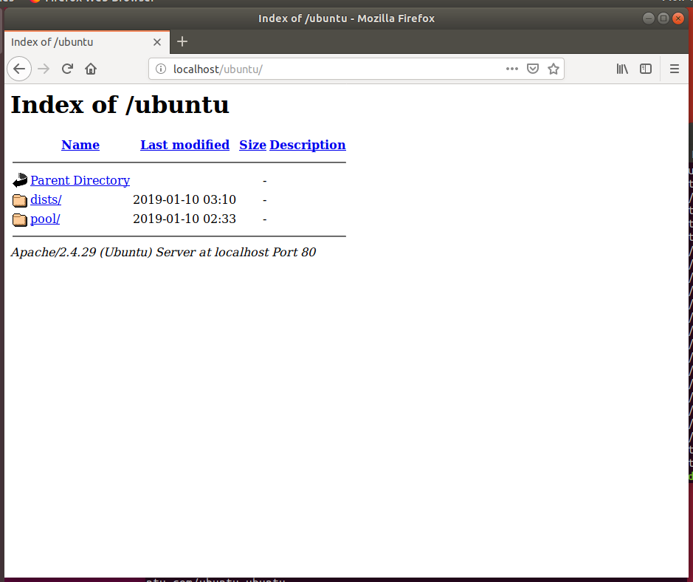

FAQ
Question #1: I got the following error when running apt-mirror, what do I do?:
flock() on closed filehandle LOCK_FILE at /usr/bin/apt-mirror line 214.
apt-mirror is already running, exiting at /usr/bin/apt-mirror line 217.
Answer #1: Most likely your <base_path> is NOT owned by the apt-mirror user. Try this:
sudo chown apt-mirror:apt-mirror <base_path>
Question #2: How do I check how much space I need?
Answer #2: Have at least 2GB on your machine, follow steps 1 to 4 and once you run the apt-mirror command, it will say the number of GB beyond the initial metadata that will be downloaded. The initial metadata is normally between 1 to 2 gigabytes.
Question #3: How do I use the repo locally?
Answer #3: Check this: AptGet/Offline/Repository

References
- Set Up A Local Ubuntu Mirror with Apt-Mirror
- apt-mirror is already running , exiting at /usr/bin/apt-mirror line 187.
- AptGet/Offline/Repository

https://help.ubuntu.com/community/AptGet/Offline/Repository

AptGet/Offline/Repository

Two different approaches exist:
- Manually copy a complete online repository to a USB keydrive and set it up as a package source for your machines.
- Use apt-medium to have the apt tools use a shared cache location (e.g. /var/cache/apt on a removable media, or network share).

Setting up a local repository

Components
As you can see in the page Repositories/Ubuntu, the Ubuntu software repository is organized into four "components", on the basis of the level of support Ubuntu can offer them, and whether or not they comply with Ubuntu's Free Software Philosophy. The components are called Main (officially supported software), Restricted (supported software that is not available under a completely free license), Universe (community-maintained, i.e. not officially supported software) and Multiverse (software that is "not free"). The standard Ubuntu installation is a subset of software available from the main and restricted components.

Download the online repository
You can download the packages in a USB keydrive in a computer with Internet connection and store them in your Ubuntu computer.
Go to this web address http://archive.ubuntu.com/ubuntu/dists/ and then to the SuiteCodename of the Ubuntu installed in your hard disk (intrepid, jaunty, karmic, ...) and download the files :
- Release
- Release.gpg
- And the Contents files for your architecture (i.e Contents-i386.gz ,if you architecture is i386).
Later, go to the component (main, multiverse, restricted, universe) and architecture (i.e. binary-i386/ in /dists/karmic/main/) that you want in your local repository, and download the files:
- Packages.bz2
- Packages.gz
- Release
Optionally, you can download the same files for the source directory (its packages are architecture independent).
Now, you have to store the files in your local Ubuntu repository in the same order. For example:
- In /home/repository/dists/karmic you would have the files: Contents-i386.gz , Release and Release.gpg
- And in /home/repository/dists/karmic/main/binary-i386 the files: Packages.bz2 , Packages.gz and Release

Add the local repository in your sources list
Use Applications -> Add/Remove as explained in Repositories/Ubuntu to add the offline repository, stored in the /home/repository directory :
deb file:///home/repository SuiteCodename main restricted universe multiverse
Where:
- SuiteCodename is intrepid, jaunty, karmic ...
- You can include some or all the components ( main, multiverse, restricted, universe).

See also
- Repositories/Ubuntu
- Repositories/Personal
- Synaptic/Offline

http://manpages.ubuntu.com/manpages/xenial/man8/apt-get.8.html
...

FILES
/etc/apt/sources.list
Locations to fetch packages from. Configuration Item: Dir::Etc::SourceList.

/etc/apt/sources.list.d/
File fragments for locations to fetch packages from. Configuration Item:
Dir::Etc::SourceParts.

/etc/apt/apt.conf
APT configuration file. Configuration Item: Dir::Etc::Main.

/etc/apt/apt.conf.d/
APT configuration file fragments. Configuration Item: Dir::Etc::Parts.

/etc/apt/preferences
Version preferences file. This is where you would specify "pinning", i.e. a preference
to get certain packages from a separate source or from a different version of a
distribution. Configuration Item: Dir::Etc::Preferences.

/etc/apt/preferences.d/
File fragments for the version preferences. Configuration Item:
Dir::Etc::PreferencesParts.

/var/cache/apt/archives/
Storage area for retrieved package files. Configuration Item: Dir::Cache::Archives.

/var/cache/apt/archives/partial/
Storage area for package files in transit. Configuration Item: Dir::Cache::Archives
(partial will be implicitly appended)

/var/lib/apt/lists/
Storage area for state information for each package resource specified in
sources.list(5) Configuration Item: Dir::State::Lists.

/var/lib/apt/lists/partial/
Storage area for state information in transit. Configuration Item: Dir::State::Lists
(partial will be implicitly appended)

SEE ALSO
apt-cache(8), apt-cdrom(8), dpkg(1), sources.list(5), apt.conf(5), apt-config(8), apt-
secure(8), The APT User's guide in /usr/share/doc/apt-doc/, apt_preferences(5), the APT
Howto.

DIAGNOSTICS
apt-get returns zero on normal operation, decimal 100 on error.

https://help.sonatype.com/repomanager3/rest-and-integration-api/repositories-api
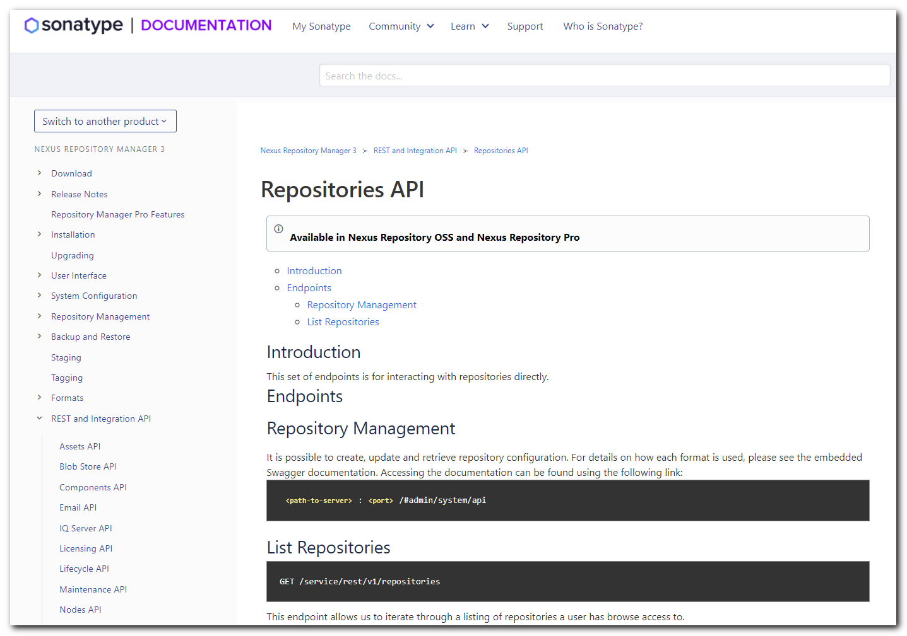
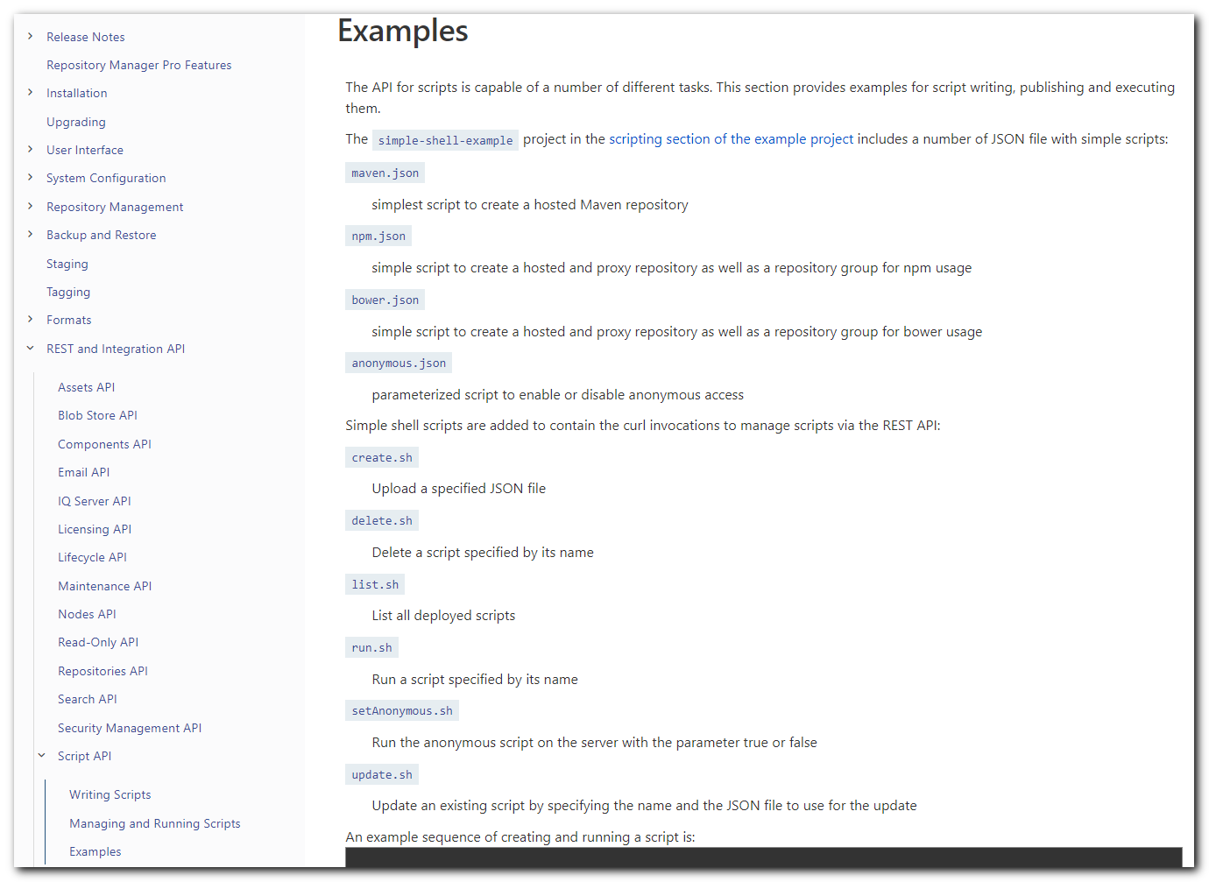

https://github.com/sonatype-nexus-community/nexus-scripting-examples/tree/master/simple-shell-example
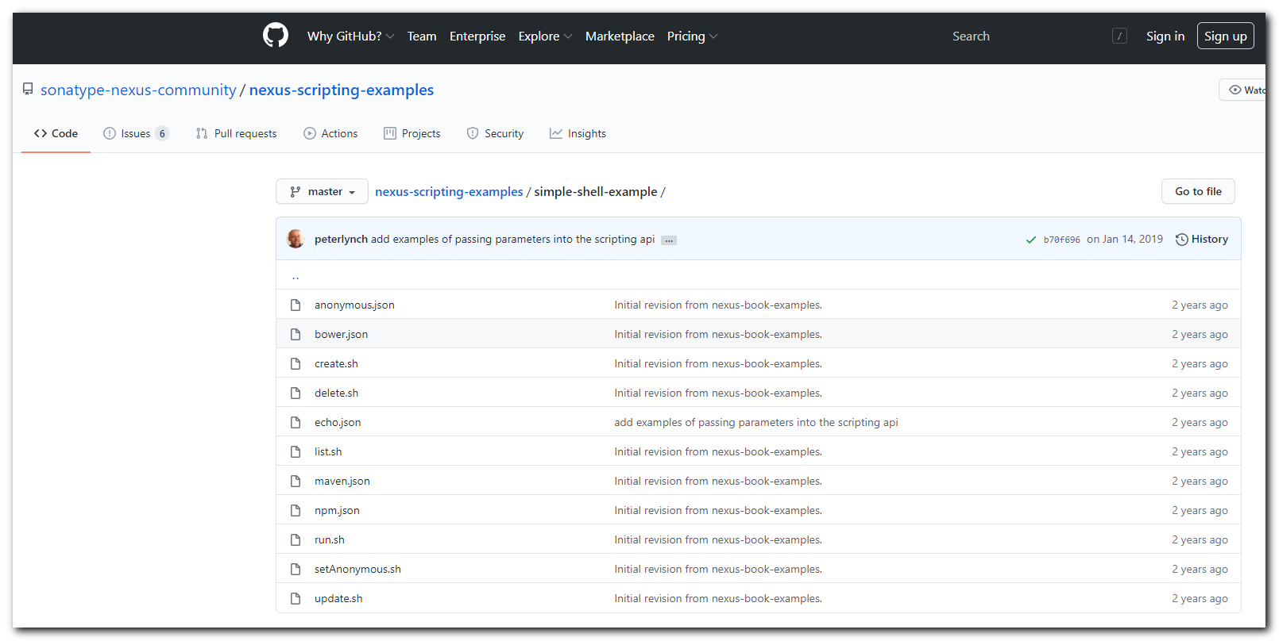

https://linuxrussia.com/apt-vs-apt-get.html


#
# 20201023
# When I executed download snapshot for ubutnu 18.04 - increased cpu.
https://fsd.tcsbank.ru/case/4567441/info
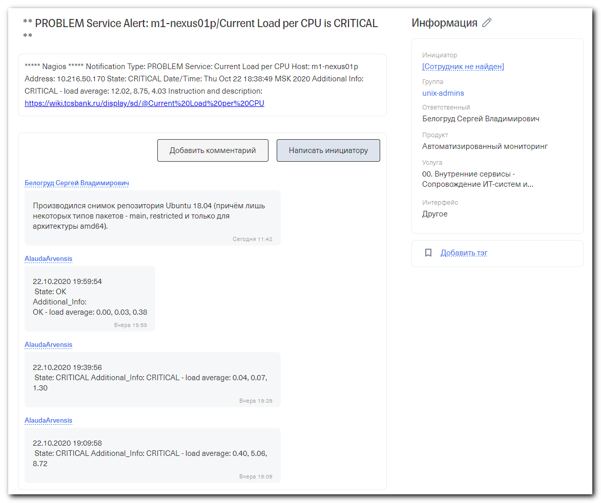

# 20201030
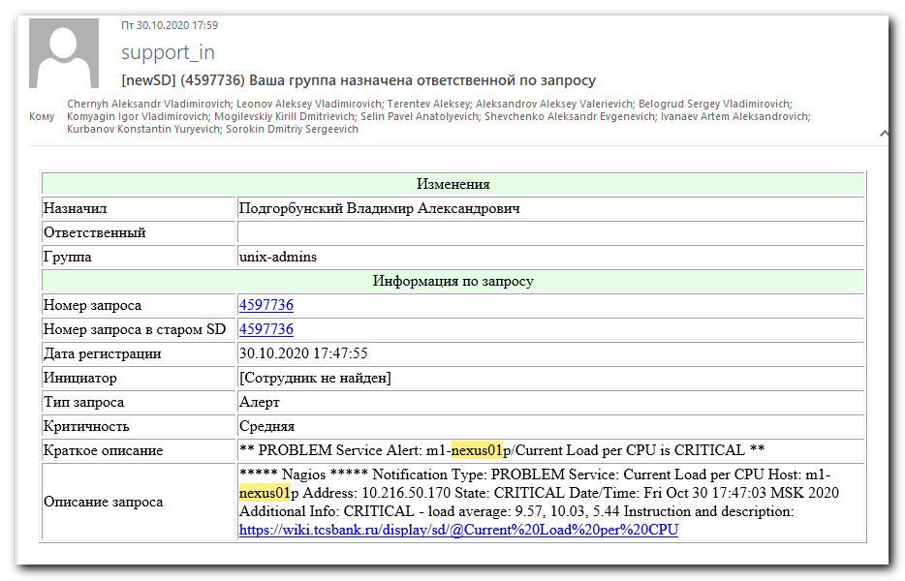

https://www.google.com/search?q=aptly&rlz=1C1GGRV_enRU751RU753&oq=aptly&aqs=chrome..69i57j0l7.2155j0j7&sourceid=chrome&ie=UTF-8
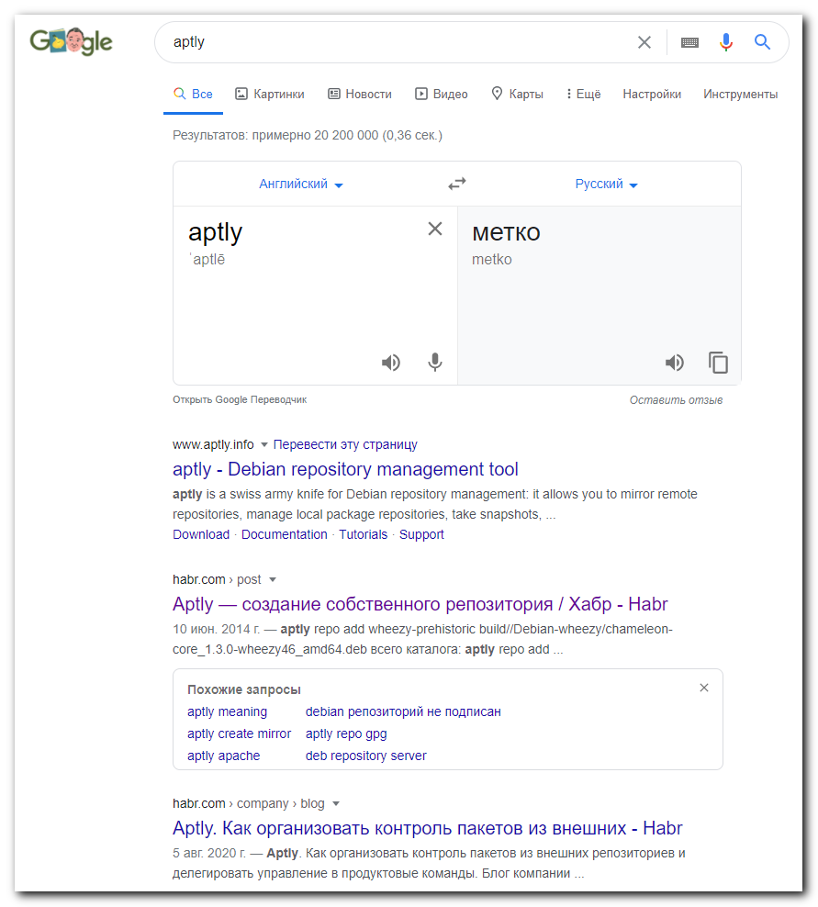

https://habr.com/ru/post/225825/

#
# 20201030
#

root@m1-nexus02p:~# date ; time apt-mirror
Fri Oct 30 17:35:19 MSK 2020
Downloading 180 index files using 20 threads...
Begin time: Fri Oct 30 17:35:20 2020
[20]... [19]... [18]... [17]... [16]... [15]... [14]... [13]... [12]... [11]... [10]... [9]... [8]... [7]... [6]... [5]... [4]... [3]... [2]... [1]... [0]...
End time: Fri Oct 30 17:35:34 2020

Processing translation indexes: [TTTTTTTTTTTTTTTTTT]

Downloading 888 translation files using 20 threads...
Begin time: Fri Oct 30 17:35:34 2020
[20]... [19]... [18]... [17]... [16]... [15]... [14]... [13]... [12]... [11]... [10]... [9]... [8]... [7]... [6]... [5]... [4]... [3]... [2]... [1]... [0]...
End time: Fri Oct 30 17:35:57 2020

Processing DEP-11 indexes: [DDDDDDDDDDDDDDDDDD]

Downloading 89 dep11 files using 20 threads...
Begin time: Fri Oct 30 17:35:57 2020
[20]... [19]... [18]... [17]... [16]... [15]... [14]... [13]... [12]... [11]... [10]... [9]... [8]... [7]... [6]... [5]... [4]... [3]... [2]... [1]... [0]...
End time: Fri Oct 30 17:36:06 2020

Processing indexes: [PPPPPPPPPPPPPPPPPP]

153.5 GiB will be downloaded into archive.
Downloading 106664 archive files using 20 threads...
Begin time: Fri Oct 30 17:38:39 2020
[20]... [19]... [18]... [17]... [16]... [15]... [14]... [13]... [12]... [11]... [10]... [9]... [8]... [7]... [6]... [5]... [4]... [3]... [2]... [1]... [0]...
End time: Fri Oct 30 18:29:57 2020

0 bytes in 0 files and 0 directories can be freed.
Run /mnt/repo_linux_repository/repo-prod/ubuntu-snapshots/ubuntu-snapshot-202010xx/var/clean.sh for this purpose.

Running the Post Mirror script ...
(/mnt/repo_linux_repository/repo-prod/ubuntu-snapshots/ubuntu-snapshot-202010xx/var/postmirror.sh)

/bin/sh: 0: Can't open /mnt/repo_linux_repository/repo-prod/ubuntu-snapshots/ubuntu-snapshot-202010xx/var/postmirror.sh

Post Mirror script has completed. See above output for any possible errors.

real 56m6.565s
user 0m53.262s
sys 3m16.782s
root@m1-nexus02p:~#

